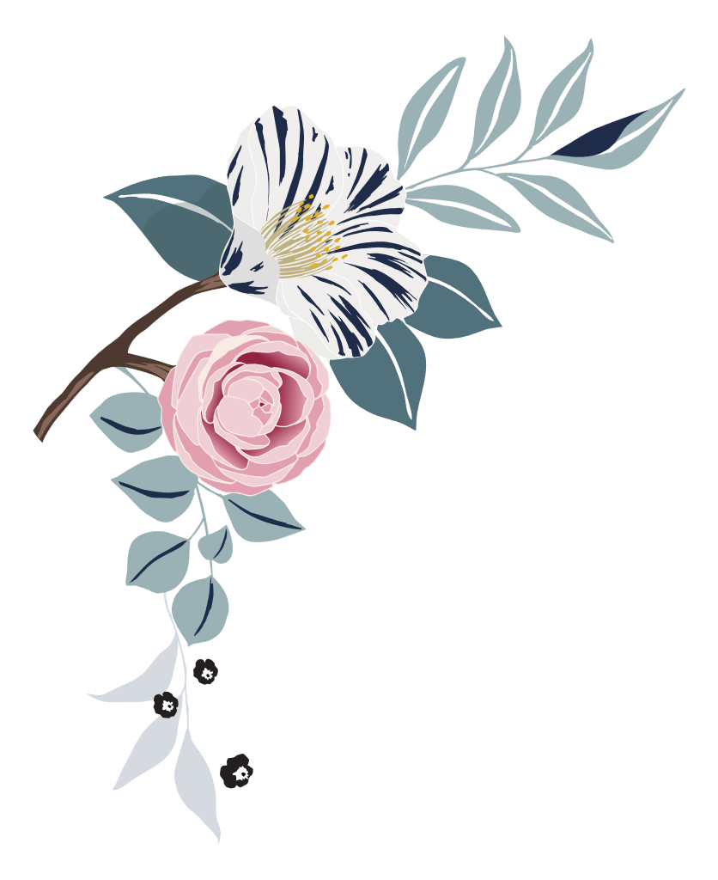

Wedding

photo checklist

|  |
| --- |
| Pre-ceremony |

|  |  |  |  |
| --- | --- | --- | --- |
| bride | | | |
| ☐ | Bride hairstyling | ☐ | Zip or buttoning of wedding gown |
| ☐ | Bride makeup application | ☐ | Bride putting on veil |
| ☐ | Wedding dress (hanging, draped) | ☐ | Bride looking in mirror |
| ☐ | Something old/new/borrowed/blue | ☐ | Bride with bouquet |
| ☐ | Wedding shoes, jewelry, veil displayed | ☐ | Click or tap here to enter text. |

|  |  |  |  |
| --- | --- | --- | --- |
| Wedding party | | | |
| ☐ | Bridesmaids’ hair and makeup | ☐ | Flower girls or junior bridesmaids with bride |
| ☐ | Bride and bridesmaids pre-wedding outfits | ☐ | Bridesmaids with bouquets |
| ☐ | Bride with Maid of Honor | ☐ | Flower girls with flower baskets |
| ☐ | Candid photos of bridesmaids dressing | ☐ | Candid photos of wedding party leaving for ceremony |

|  |  |  |  |
| --- | --- | --- | --- |
| Bride’s family | | | |
| ☐ | Bride with mother | ☐ | Bride pinning mother’s corsage |
| ☐ | Mother of bride adjusting veil | ☐ | Bride pinning father’s boutonniere |
| ☐ | Bride with father | ☐ | Candid photos of bride’s family leaving for ceremony |

|  |  |  |  |
| --- | --- | --- | --- |
| Groom | | | |
| ☐ | Groom tying tie | ☐ | Groom with father |
| ☐ | Groom putting on boutonniere | ☐ | Groom with groomsmen |
| ☐ | Groom looking in mirror | ☐ | Groom with ring bearer |
| ☐ | Groom with best man | ☐ | Groomsmen putting on boutonnieres |
| ☐ | Groom with mother | ☐ | Candid photos of groom and groomsmen leaving for ceremony |

|  |
| --- |
| at the ceremony |

|  |  |  |  |
| --- | --- | --- | --- |
| ☐ | Church/venue exterior | ☐ | Groom’s first sight of bride |
| ☐ | Church/venue interior (empty) | ☐ | Bride and escort entering |
| ☐ | Officiant with groom | ☐ | Bride and escort from rear of venue |
| ☐ | Guests arriving | ☐ | Bride “given away” |
| ☐ | Bride arriving | ☐ | Musical performances and special readings |
| ☐ | Groom arriving | ☐ | Unity ceremonies or memorials |

|  |  |  |  |
| --- | --- | --- | --- |
| ☐ | Musicians and soloists | ☐ | Communion, eucharist, or other religious ceremonies |
| ☐ | Seating of grandparents | ☐ | Exchange of vows |
| ☐ | Seating of parents | ☐ | Exchange of rings |
| ☐ | Groom and officiant entering | ☐ | Candid photos of children in wedding party |
| ☐ | Entrance of children | ☐ | The kiss |
| ☐ | Entrance of wedding party | ☐ | Introduction and applause |
| ☐ | Guests standing for bride | ☐ | Recessional |
| ☐ | Bride and escort framed in doorway | ☐ | Wedding couple with attendants after ceremony |

# 

|  |
| --- |
| Formal photos |

|  |  |  |  |
| --- | --- | --- | --- |
| ☐ | Wedding musician’s close-up | ☐ | Groom alone |
| ☐ | Invitation close-up | ☐ | Wedding couple together |
| ☐ | Altar or chuppah | ☐ | Wedding couple with officiant |
| ☐ | Bride alone | ☐ | Rings close-up |

|  |  |  |  |
| --- | --- | --- | --- |
| Family photos | | | |
| ☐ | Bride with bride’s family | ☐ | Wedding couple with bride’s parents |
| ☐ | Bride with groom’s family | ☐ | Bride with bride’s grandparents |
| ☐ | Groom with bride’s family | ☐ | Wedding couple with bride’s grandparents |

|  |  |  |  |
| --- | --- | --- | --- |
| ☐ | Groom with groom’s family | ☐ | Groom with groom’s parents |
| ☐ | Wedding couple with bride’s family | ☐ | Groom with mother |
| ☐ | Wedding couple with groom’s family | ☐ | Groom with father |
| ☐ | Wedding couple with both families | ☐ | Groom with groom’s grandparents |
| ☐ | Bride with bride’s parents | ☐ | Wedding couple with groom’s parents |
| ☐ | Bride with mother | ☐ | Wedding couple with groom’s grandparents |
| ☐ | Bride with father | ☐ | Couple with siblings |

|  |  |  |  |
| --- | --- | --- | --- |
| Attendants | | | |
| ☐ | Bride with maid of honor | ☐ | Groom with groomsmen |
| ☐ | Groom with best man | ☐ | Wedding couple with groomsmen |
| ☐ | Bride with wedding attendants | ☐ | Bride with child attendants |
| ☐ | Groom with wedding attendants | ☐ | Groom with child attendants |
| ☐ | Wedding couple with wedding attendants | ☐ | Wedding couple with child attendants |
| ☐ | Bride with groomsmen | ☐ | Lorem ipsum dolor sit amet |

|  |
| --- |
| Reception photos |

|  |  |  |  |
| --- | --- | --- | --- |
| ☐ | Exterior of reception venue (empty) | ☐ | Groom’s dance with mother |
| ☐ | Interior of reception venue (empty) | ☐ | Parents dancing |

|  |  |  |  |
| --- | --- | --- | --- |
| ☐ | Arrival at reception venue | ☐ | Grandparents dancing |
| ☐ | Wedding cake | ☐ | Guests dancing |
| ☐ | Bar setup | ☐ | Wedding couple greeting guests |
| ☐ | Groom’s cake | ☐ | Cake cutting |
| ☐ | Buffet and servers | ☐ | Cake feeding |
| ☐ | Band or DJ | ☐ | Speeches/toasts |
| ☐ | Gift table | ☐ | Bride tossing bouquet |
| ☐ | Centerpieces | ☐ | Groom removing garter |
| ☐ | Floral arrangements | ☐ | Groom throwing garter |
| ☐ | Favors | ☐ | Bouquet and garter catchers dancing |
| ☐ | Entrance of wedding party | ☐ | Bride and groom’s last dance |
| ☐ | Entrance of wedding couple | ☐ | Decorated “just married” car |
| ☐ | Bride and groom’s first dance | ☐ | Wedding couple exiting venue |
| ☐ | Bride’s dance with father | ☐ | Guests at exit (throwing birdseed, blowing bubbles, etc.) |
| ☐ | Centerpieces | ☐ | Wedding couple in car waving goodbye |